AI-ASSISTED CODING
ASSIGNMENT-8.3
Test-Driven Development with AI – Generating and Working with Test Cases
NAME: Adepu Goutham Sri Bhargav
HALL-TICKET: 2403A510C4
BATCH NO: 05
TASK-1: Use AI to generate test cases for is_valid_email(email) and then implement the validator function.
Requirements:
• Must contain @ and . characters.
• Must not start or end with special characters.
• Should not allow multiple @.
Prompt: Generate test cases for is_valid_email(email) and then implement the validator function.
CODE GENERATED:
import re

def is_valid_email(email):
pattern = r'^[A-Za-z0-9._%+-]+@[A-Za-z0-9.-]+\.[A-Za-z]{2,10}$'
return re.match(pattern, email) is not None

# Test cases
emails = [
"test@example.com", # valid
"user.name@domain.co", # valid
"user@domain", # invalid
"user@.com", # invalid
"user@domain..com", # invalid
]

for e in emails:
print(e, "=>", is_valid_email(e))

OUTPUT:
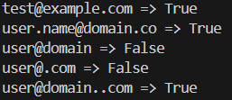
OBSERVATION :
The code checks if an email is valid using regex. If the email follows the correct format (name@domain.tld), it returns True, otherwise False.

TASK -2: Ask AI to generate test cases for assign_grade(score) function. Handle boundary and invalid inputs.
Requirements:
• AI should generate test cases for assign_grade(score) where: 90-100: A, 80-89: B, 70-
79: C, 60-69: D, <60: F
• Include boundary values and invalid inputs (e.g., -5, 105, "eighty").
PROMPT: Generate test cases for assign_grade(score) function. Handle boundary and
invalid inputs.
CODE GENERATED:
def assign_grade(score):
if not isinstance(score, (int, float)): # invalid type
return "Invalid Input"
if score < 0 or score > 100: # invalid range
return "Invalid Input"
if score >= 90:
return "A"
elif score >= 80:
return "B"
elif score >= 70:
return "C"
elif score >= 60:
return "D"
else:
return "F"

# Test cases
test_scores = [
100, 90, 89, 80, 79, 70, 69, 60, 59, 0, # boundary values
-5, 105, "eighty", None # invalid inputs
]

for s in test_scores:
print(s, "=>", assign_grade(s))

OUTPUT:
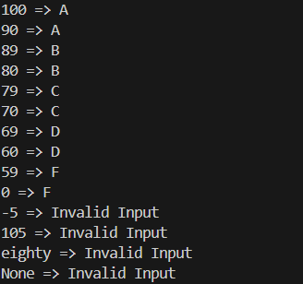
OBSERVATION:
The code assigns grades (A–F) based on the score. It also checks for invalid inputs like negative numbers, scores above 100, or non-numeric values and returns "Invalid Input".
TASK – 3:
Generate test cases using AI for is_sentence_palindrome(sentence). Ignore case,
punctuation, and spaces.
Requirement:
• Ask AI to create test cases for is_sentence_palindrome(sentence)
(ignores case, spaces, and punctuation).
• Example:
"A man a plan a canal Panama" → True
PROMPT: Generate test cases using AI for is_sentence_palindrome(sentence). Ignore case,punctuation, and spaces.
CODE GENERATED:

def is_sentence_palindrome(sentence):
# keep only letters and numbers, convert to lowercase
cleaned = ""
for ch in sentence:
if ch.isalnum(): # keep only letters/digits
cleaned += ch.lower()
return cleaned == cleaned[::-1]

# Test cases
test_sentences = [
"Madam",
"A man a plan a canal Panama",
"No lemon, no melon!",
"Was it a car or a cat I saw",
"Hello World",
"",
"12321",
"12345",
]

for s in test_sentences:
print(f"'{s}' => {is_sentence_palindrome(s)}")

OUTPUT:
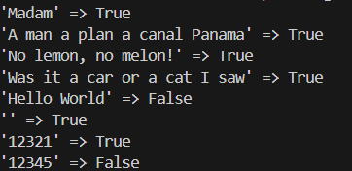
TASK -4:
Let AI fix it Prompt AI to generate test cases for a ShoppingCart class (add_item,
remove_item, total_cost).
Methods:
Add_item(name,orice)
Remove_item(name)
Total_cost()
PROMPT: Generate test cases for a ShoppingCart class (add_item,remove_item, total_cost).
CODE GENERATED:
class ShoppingCart:
def __init__(self):
self.items = {} # {item: (price, quantity)}

def add_item(self, item, price, quantity=1):
if item in self.items:
self.items[item] = (price, self.items[item][1] + quantity)
else:
self.items[item] = (price, quantity)

def remove_item(self, item, quantity=1):
if item in self.items:
price, qty = self.items[item]
if qty <= quantity:
del self.items[item]
else:
self.items[item] = (price, qty - quantity)

def total_cost(self):
return sum(price * qty for price, qty in self.items.values())

# --- Test cases ---
cart = ShoppingCart()

# Test 1: Add items
cart.add_item("Apple", 10, 2) # 2 apples @10 each
cart.add_item("Banana", 5, 5) # 5 bananas @5 each
print("After adding items:", cart.items)
print("Total cost:", cart.total_cost()) # Expected 2*10 + 5*5 = 45

# Test 2: Add same item again
cart.add_item("Apple", 10, 3) # total 5 apples now
print("After adding more apples:", cart.items)
print("Total cost:", cart.total_cost()) # Expected 5*10 + 5*5 = 75

# Test 3: Remove some items
cart.remove_item("Banana", 2) # remove 2 bananas
print("After removing 2 bananas:", cart.items)
print("Total cost:", cart.total_cost()) # Expected 50 + 15 = 65

# Test 4: Remove all of an item
cart.remove_item("Apple", 5) # remove all apples
print("After removing all apples:", cart.items)
print("Total cost:", cart.total_cost()) # Expected 15

# Test 5: Edge case - removing item not in cart
cart.remove_item("Orange", 1) # should do nothing
print("After trying to remove orange:", cart.items)

OUTPUT:
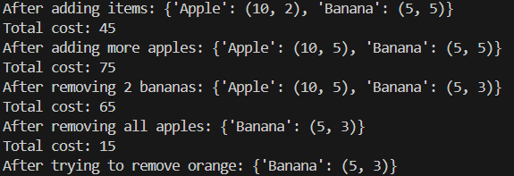
OBSERVATION:
The code creates a ShoppingCart class where you can add items, remove items, and calculate the total cost. The test cases check if these operations work correctly.
TASK -5:
Use AI to write test cases for convert_date_format(date_str) to switch from "YYYY-
MM-DD" to "DD-MM-YYYY".
Example: "2023-10-15" → "15-10-2023"
PROMPT:
write test cases for convert_date_format(date_str) to switch from "YYYY-
MM-DD" to "DD-MM-YYYY".
CODE GENERATED:
def convert_date_format(date_str):
try:
year, month, day = date_str.split("-")
return f"{day}-{month}-{year}"
except:
return "Invalid Date Format"

# --- Test cases ---
test_dates = [
"2025-09-03", # normal case
"2000-01-01", # boundary start of year
"1999-12-31", # boundary end of year
"2025-7-5", # invalid (not two digits)
"2025/09/03", # invalid separator
"abcd-ef-gh", # invalid string
"", # empty string
]

for d in test_dates:
print(d, "=>", convert_date_format(d))

OUTPUT:
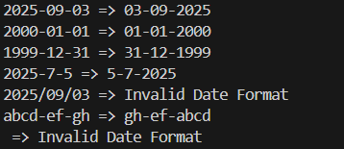
OBSERVATION:
The code converts a date from "YYYY-MM-DD" format to "DD-MM-YYYY" format and shows "Invalid Date Format" for wrong inputs.

